Cromwell Group Endurance GB
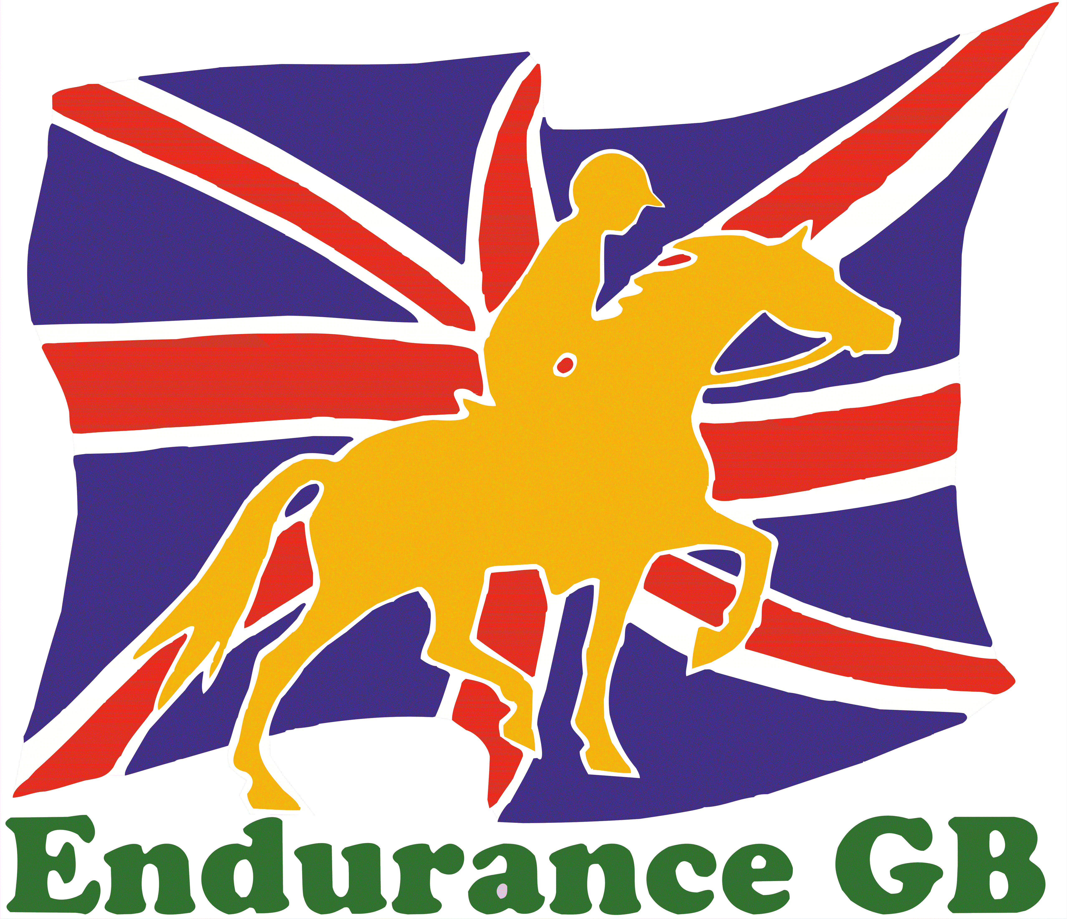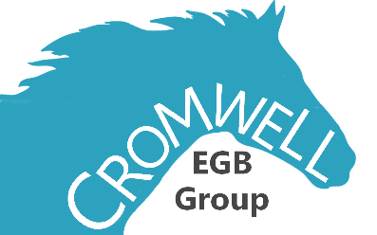
BAM Committee Meeting
Working Men’s Club Ringstead.
12 High St, Ringstead, NN14 4DA
12th January 2019 ~ 7.30pm

MINUTES

- Apologies
Alison Taylor
- Minutes of Previous Meeting
Approved
- Approval of Minutes
1st –Bella Fricker, 2nd- Helen Gibson.
- Matters Arising
None
- Chairman’s Report
Chairman’s Report 2018 Season.
Our group keeps growing each year which is good having 74 members in 2018.
We have a good number of Young, Junior Riders and hope they enjoy Endurance Riding for a long time to keep our sport going with new young blood in the group.
We only had 3 competitive rides last year, Keysoe, Hanslope and reinstated Three Shires ride.
All had a good entry in the end making it worthwhile but a headache for the organisers wondering if they had to cancel the ride so please enter before the closing date. The closing date is there for a reason so as the RO know numbers and can engage the correct number of vets etc. to run the ride.
We had a few PR? Training rides which were all well supported and full to capacity,
So thank you all for supporting these rides as these provide income for our group.
Rides for 2019 are exciting:
- Concrete Cows is back on at the new venue in March
- Three Shires in June
- Hanslope as a FEI in October
- Keysoe we are still trying to sort out RO etc. so watch this space.
There are training rides on the calendar and more might be added as people offer to run one.
- Green Barn in August 2019
- Ride &amp; Stride in MK area 28th September 2019 which is a 14km ride
Riders Success.
Our Cromwell Riders have had great success in 2018 especially our Young Riders
- Ollie Holman Represented GB @ the Young Riders European Championships in Pisa. That was a great achievement for him and his team, so very well done Ollie
- Sophie Moorhouse had great success in FEI 1* @ Euston Park coming 2nd in the Young Rider 1* and getting 2nd place in Best Condition, This all being in her 1st season as an Advanced rider so again very well done to you and your team.
- Bella Fricker did very well in the 120km Nations cup at Euston being the 2nd British rider home so again well done to you and your team.
There is great comaradie within Endurance Riders always helping and when you can’t ride due to horse or rider injury then the rider offers to help at rides. Please keep this up as we need all the volunteers to make these rides work for you all as riders to enjoy your sport. So as riders always smile and thank the volunteers.

Training
We put a lot of training on to help horse and rider:
- Canter training at various places
- Bio-Mechanics on and off the horse
- New was Pole-work clinics running once a month
- We have organised A Seminar again next week focusing on the horse fitness with pop up shops and refreshments.
- We have had to cancel the weekend training as the venue was not right but we are trying to organise another one.
Inter-Regional Team:
Anna was our Chef d Equip and organised the team with a training session. We fielded a full team which was taken over on the day by Bella as Anna was too close to her next exciting chapter in her life (Having a baby). Cirencester was not kind to our horses last year due to heat and hard ground. WE finished in 8th place. Bella had organised some great kit from Noble Outfitters at greatly reduced price. Our team looked very smart. We try to gather money towards the inter-regionals every year usually by cake stalls (Camborne ride donations are £35 to start the ball rolling).
We are fielding a team again at Cirencester. So please put your name forward to Alison Taylor as she has offered to be Chef this year, Watch the space as she hopes to run a training ride to raise money for prospective team members to be watched and assessed to be helped on their Endurance journey.
Cromwell Challenge will be going ahead for 2019 so get your cards signed it will include points for all PR training events so Camborne Riders and Pole-work clinic riders get them signed now. EGB have introduced new Foundation 26km GER in the calendar so exciting for young/old horses.
- Mileage will count.
- Loyalty Cards please use them on the tables
- Everyone please Subscribe to the website.
- Lastly a big thank you to all RO for 2018 and all the volunteers who helped at many rides of training events throughout the year.
- Treasurer’s Report
Opening Cash Balance= £3,492.00.
Income:
Reason for income. | Amount in.
Training Rides and Pleasure Rides. | £2,481.00
Training Events. | £2,307.00
Associate Subscriptions. | £77.00
BAM income. | £455.00
Inter-regionals Kit sales. | £407.00
Fundraising. | £43.00
Total Income. | £5,770.00
Expenditure 2018:
Reason for Expenditure. | Amount Spent.
Ride Expenses. | £1,248.00
Training Expenses. | £1,749.00
BAM Awards. | £680.00
Equipment Purchases. | £230.00
Inter-regionals Kit. | £646.00
Travel Expenses. | £110.00
EGB Welfare Expenses. | £90.00
Golden Horseshoe ride sponsor. | £250.00
Online Booking Fee’s. | £54.00
Printing. | £17.00
Total Expenditure. | £5,075.00
Surplus for the year: £695.00
Closing cash Balance: £4,187.00.
- Thank you to Martin and Sue Cox for hosting the Camborne ride which was our largest fund-raising event.
- Online booking commenced October 2018, Thanks to Bella Fricker.
- Focus for 2019, will be replacing the group caravan with a trailer to store and move ride equipment, cost in excess of £2,000.00.
- Election of Officers- Treasurer, Secretary, Committee
Committee is staying the same as last year, other than the addition of a junior member Suzie Todd.
- AOB
Nothing.
- Award Presentation

- Date of Next Meeting
13th March 2019.

