Schedule kindly sponsored by
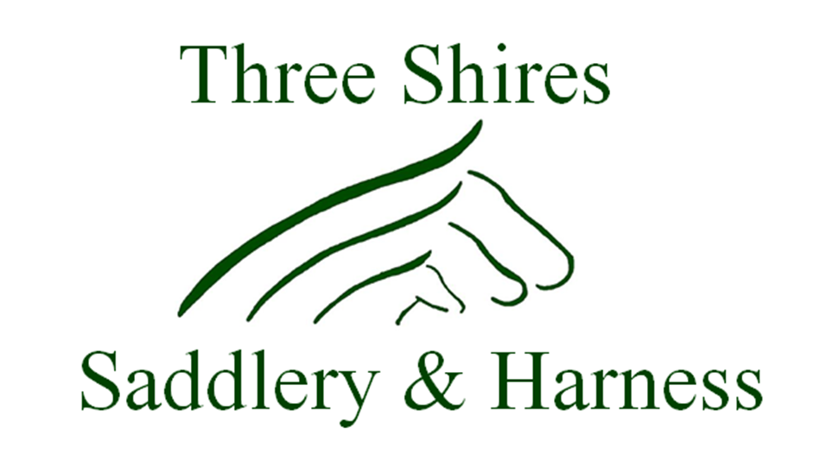
Bespoke saddlery, harness and all other leather goods - all handmade to order and hand stitched to achieve a long lasting and quality finish.
Repairs– no job too big or too small. Get those repairs done ready for the summer! Get in touch now and we can collect your repairs from the Secretary’s tent on the day of the ride.
Call 01480 890203, email threeshires.saddlery@aol.co.uk,
find us on facebook or visit www.threeshires-saddlery.com

About Woodhurst Group RDA

Each week the group gives 8 disabled children the opportunity to ride a pony. The riding sessions are of great benefit to the children whose ages range from 4 to 7 years. Riding is recommended by medical professionals, offers great physiotherapy and is suitable for children with physical and learning difficulties. The advances we see with our children can be enormous; helping not only with movement and balance but also many other aspects of learning such as numeracy, reading, communication, problem solving and independence.

Our sessions run from 10-12 noon on Mondays at Northbrook Equestrian Centre. We are always looking for volunteers, please get in touch if you can spare the time to join us.

Woodhurst Group Riding for the Disabled

CHARITY PLEASURE RIDE
Registered Charity 1164390

ABBOTS RIPTON ESTATE, GRANGE FARM, ABBOTS RIPTON, HUNTINGDON, PE28 2PH
By kind permission of Lord and Lady De Ramsey

SUNDAY 5 MAY 2019

6 or 12 mile course (approx)
(There are some short stretches of roadwork)

Please park at, and start ride from
Grange Farm, PE28 2PH
Riders may start the course between
9.30 am and 12.30 pm
Hot and cold refreshments will be available

Entry fees
Short route £13.00
Long route £18.00
Late entries/or on the day £5.00 extra
All riders will be charged a £5 refundable deposit for the numbered bib.

Entries to: Brenda Eade, 1 Chapel Close, Hartford, Huntingdon, PE29 1AR; by 18 April 2019
(Tel no: 07801704411)
Email: Brenda.eade@googlemail.com
Emergency phone contact on the day
Christine Dolby: 07974 806896
Caroline Leafe: 07719 102690

Conditions of entry

- The appropriate entry fee must be enclosed with the Entry form and be received by the Secretary, Brenda Eade by 18 April 2019.

- Riders must report to the Secretary on arrival to collect a number to wear and on completion of the ride to confirm your return and collect a rosette

- In case of bad weather, please check the Horse Dates website or phone Secretary to see if cancelled.

- The organisers will not accept liability for any damage, illness, loss, accident or injury to any animal, person, vehicle or property.

- The ride starts and finishes at the same point and will be marked and stewarded. It is recommended that each group of riders have a mobile phone for emergencies. Riders can retire at any checkpoint should they wish, but must report to a steward so they can notify the start.

- All competitors MUST when mounted wear a riding hat to the current PAS015 or better standard and hard heeled footwear must be worn. High visibility wear is recommended.

- Riders are expected to show due consideration to other riders and the property over which they ride. The organisers reserve the right to ask any rider to leave the course.

- Please keep to the marked course, especially along trails and headlands.

- Official cars only will be allowed on the course.

- Any dogs must be kept on leads at all times.

- All riders must hold third party liability insurance, through club membership or privately to the value of £5m or above.

- All juniors 16 years and under must be accompanied by an adult.

- A First Aider will be present and a Veterinary Surgeon will be on call.

- Horse box parking is at Grange Farm, Abbots Ripton PE28 2PH

- Riders are asked to pass others in a courteous manner, never faster than a trot.

WOODHURST RDA PLEASURE RIDE ENTRY FORM

Sunday 5 May 2019
Entry into this event signifies acceptance of the conditions.

Name

Address

Tel No:

Email:

Mobile No to be carried on the day: ……………………………………

Date of Birth for Riders under 18 years of Age …………………...….

Emergency Telephone No on day of ride............................................

Name of contact............................. Relationship.................................

Please tick Ride Length .............6 Miles ...............12 Miles

Cheque enclosed for .....................................................
(Cheques to be made payable to Woodhurst Group RDA)

Or Paypal to Woodhurst.rda@aol.co.uk with the surname of the person making this entry as the reference.

Please detail any pre-existing medical condition we need to know about - eg asthma, diabetes, allergy ..................................................

I am a BHS Gold/Riding/Pony Club Member: Yes/ No
Or I have private third party liability insurance: Yes/No
I am an Endurance GB Member: Quote number

I accept the conditions of entry.

Signature .............................................................................................

WOODHURST RDA PLEASURE RIDE ENTRY FORM

Sunday 5 May 2019
Entry into this event signifies acceptance of the conditions.

Name

Address

Tel No:

Email:

Mobile No to be carried on the day: ……………………………………

Date of Birth for Riders under 18 years of Age …………………...….

Emergency Telephone No on day of ride............................................

Name of contact............................. Relationship.................................

Please tick Ride Length .............6 Miles ...............12 Miles

Cheque enclosed for .....................................................
(Cheques to be made payable to Woodhurst Group RDA)

Or Paypal to Woodhurst.rda@aol.co.uk with the surname of the person making this entry as the reference.

Please detail any pre-existing medical condition we need to know about - eg asthma, diabetes, allergy ..................................................

I am a BHS Gold/Riding/Pony Club Member: Yes/ No
Or I have private third party liability insurance: Yes/No
I am an Endurance GB Member: Quote number

I accept the conditions of entry.

Signature .............................................................................................

WOODHURST RDA PLEASURE RIDE ENTRY FORM

Sunday 5 May 2019
Entry into this event signifies acceptance of the conditions.

Name

Address

Tel No:

Email:

Mobile No to be carried on the day: ……………………………………

Date of Birth for Riders under 18 years of Age …………………...….

Emergency Telephone No on day of ride............................................

Name of contact............................. Relationship.................................

Please tick Ride Length .............6 Miles ...............12 Miles

Cheque enclosed for .....................................................
(Cheques to be made payable to Woodhurst Group RDA)

Or Paypal to Woodhurst.rda@aol.co.uk with the surname of the person making this entry as the reference.

Please detail any pre-existing medical condition we need to know about - eg asthma, diabetes, allergy ..................................................

I am a BHS Gold/Riding/Pony Club Member: Yes/ No
Or I have private third party liability insurance: Yes/No
I am an Endurance GB Member: Quote number

I accept the conditions of entry.

Signature .............................................................................................

