CROMWELL EGB GROUP, CHILTERN DISTANCE RIDERS
AND WHADDON CHASE PONY CLUB
Ride and Stride – Supporting Bucks Historic Churches Trust
Starting from the Events Plateau in Campbell Park Milton Keynes
on Sunday September 29th 2019.

Open 14 km Charity Ride

On a route of dedicated bridle paths with limited road work through quiet estates. The route will be stewarded. Maps will be provided. There are no jumps. Entries in advance. Riding in groups of 2 – 5 riders. Each group will be allocated a start time.

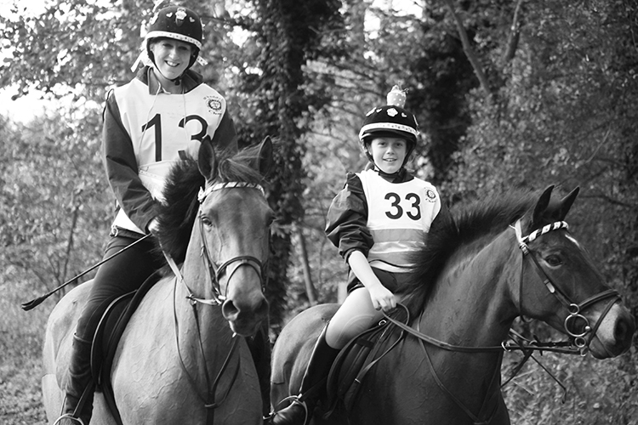
This ride offers the chance to explore some of the wonderful dedicated bridleways in Milton Keynes and do a little sight-seeing of some of our more historic buildings at the same time. All riders will be issued with a card listing the churches they are passing on the route and explaining a little about their history. Half way round there is the opportunity to stop for a (non-alcoholic) stirrup cup and snacks.

A fun and relaxing day out for all the family. All entrants completing the ride successfully will receive a completion rosette.
(photo courtesy of Luru Wei Photography)

RULES:

- Pony Club rules apply to PC members. (please consult current rule book for details). This ride will count as a Merlin Level 2 Ride for mileage badges.
- All riders must be at least 5 years old on 1/1/2019.
- Leading is permitted from the ground or from horseback only. Bike riders are not permitted to escort in any class.
- Riders under 13 years of age on the day of the ride must be accompanied by an adult rider of 18 years or over with a maximum ratio of two children to each adult.
- All horses competing must be at least 4 years old.
- All classes are suitable for any size/type of equine and entrants need not be Pony Club, CDR or EGB members.
- At least one member of each group to carry a mobile phone whose number has been advised to the ride secretary.
- RDA/EGB para endurance rules apply to additional equipment/escorts required by disabled riders.
- All hats must be worn with chin strap correctly fastened at all times when mounted. All competitors must comply. Hats must comply with current rule book. Pony Club members should be riding in a hat which has been tagged to show that it is fully compliant.

LIABILITY:
Neither the Organisers, nor any person acting on their behalf, accept any liability for any loss, damage, accident, injury or illness to horses, competitors, spectators or any person or property whatsoever.

ENTRIES:
- £15.00 per riding entry (of which £5 will be donated to Bucks Historic Churches Trust)
- Riders are invited to donate or collect additional sponsorship money
- Entries close 15/09/2019. Please note that this will be strictly adhered to in order to allow paperwork/maps to be sent out.
- Cheques payable to Milton Keynes Horse Ride
- If you are unable to send a cheque then please contact Ride Organiser to discuss alternative payment methods. Please do not send cash through the post
- Queries by email please – especially in the week prior to the event.
- Maps etc will be sent by email. Please ensure that your email address is written clearly on the entry form! If you do not have an email address please enclose A4 or A5 SAE with large letter postage for maps/times and send completed forms to:

Nikki Parsler,
28 Hazelwood,
Great Linford,
Milton Keynes.
MK14 5DU

Tel: 0844 414 2738 (local call rate)
email: nikki@nspresources.co.uk

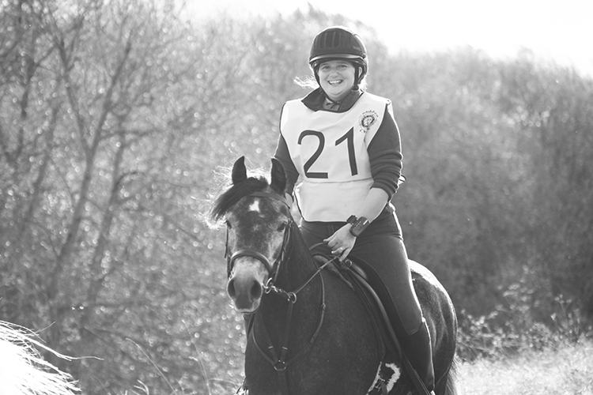

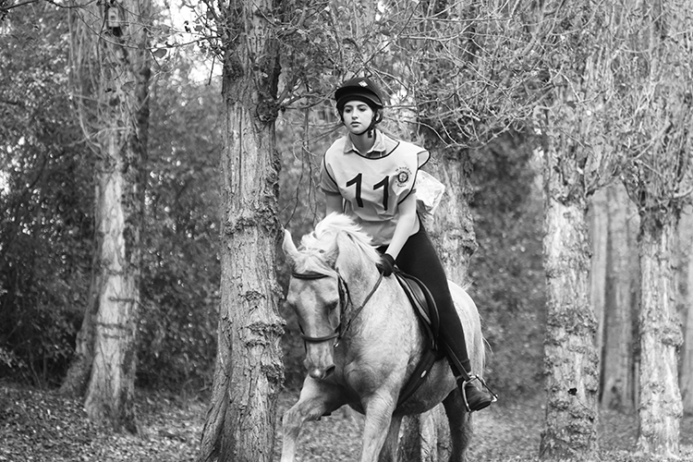
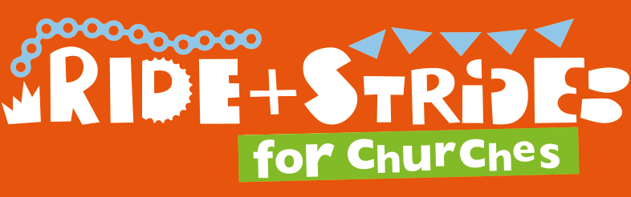

Cromwell EGB/CDR/Whaddon Chase Branch of the Pony Club
Ride and Stride 29th September 2019 Entry Form

IF ME IF RIDERS ARE UNDER 13 YEARS OF AGE, THEY MUST BE ACCOMPANIED BY AN ADULT (18YRS +) WHO CAN ENTER FOC. PLEASE NOTE THAT ALL ACCOMPANYING RIDERS MUST ENTER IN ADVANCE. NO RIDERS WILL BE PERMITTED TO ACCOMPANY COMPETITORS IF NOT ENTERED THEMSELVES. NO ENTRIES TAKEN ON THE DAY.

Rider | Age | Horse/Pony | Height | Entry fee  £15
Additional Donation to Bucks Historic Churches |  | TOTAL FEES

Name……………………………………………………………………….

Address………………………………………………………………………………………………………..

Telephone number………………………

email address (please print clearly) ………………………………………………………..……………….

Mobile phone number to be taken on the ride……………………………......................................................

Emergency contact number…………………………………………………………………………………...

Name of Pony Club/EGB/RDA/CDR Branch (if applicable) ……………………………………………………

Entries Close Friday 15th Sept 2019 – late entries not accepted

IF THEY ENTER, I WISH TO RIDE IN A GROUP WITH THE FOLLOWING, (MAXIMUM OF 5 PER GROUP.. IF YOU ARE A LONE RIDER OR YOUR FRIEND DOESN’T ENTER WE MAY FIT YOU WITH ANOTHER GROUP UNLESS YOU EXPRESSLY ASK US NOT TO.

RIDER HORSE/PONY

1……………………………………………………………………………………………………………………….

2……………………………….…………….…….………………………………………………………………….

3………………………………..…………….……………………………………………………………………….
4.
4 ……………………………………………………………………………………………………………………………..

Entries to: Nikki Parsler, 28 Hazelwood, Great Linford, Milton Keynes. MK14 5DU

Cheques made payable to Milton Keynes Horse Ride

